# COMP7500/7506 Lecture 06: Project 2-2 pWordCount - Design

**🟊: >85%, 🟊🟊: 70-85%, 🟊🟊🟊: 55-70%, 🟊🟊🟊🟊: 40-55%, 🟊🟊🟊🟊🟊: < 40%**

**🟊 Exercise 1:** In the following source code, what does the third argument (i.e., strlen(write_msg)+1) in write() mean? Why this argument is strlen(write_msg)+1 rather than strlen(write_msg)?

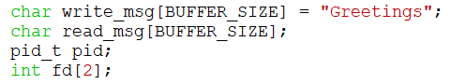

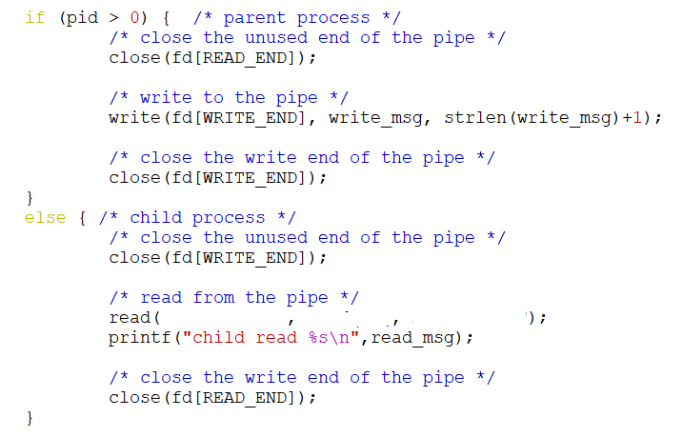

**🟊🟊🟊 Exercise 2:** In the above source code, what are the three arguments in read()?

**🟊🟊🟊 Exercise 3:** How to implement error-checking case 1 (i.e., no input file name)?

**🟊🟊🟊 Exercise 4:** How to implement error-checking case 1 (i.e., no input file name)?

How to implement error-checking case 2 (i.e., file doesn’t exist) and case 3 (i.e., file can’t open)?

**Exercise 5 (Data Flow Diagram):** Please design a data flow diagram for pWordCount.

* Mark data on each arrow
* Pay attention to:
  + Input and output
  + Data store
  + Don’t consider the details of data structures
* Do NOT consider controls (i.e., algorithms)

**Exercise 5.1:** Please provide a list of modules in your data flow diagram.

**Exercise 5.2:** Please provide a list of internal data storage in your data flow diagram.

**Exercise 5.3 (put it all together):** Please connect the modules and internal data storage.